Group 17 Worksheet 15
Date: 7.2.16
Excel Graphing / Formula Developed by Tanner:
Excel formula used to plot up to 80: =IF(B2>40, 40+20+10+5, IF(B2>20, 20+10+5, IF(B2>10, 10+5, IF(B2>5, 5, 0)))) + B2
Answer to Worksheet (n=25 analysis)
N=25
COST = 60
Average Cost per insertion @ 25 = 2.4 units
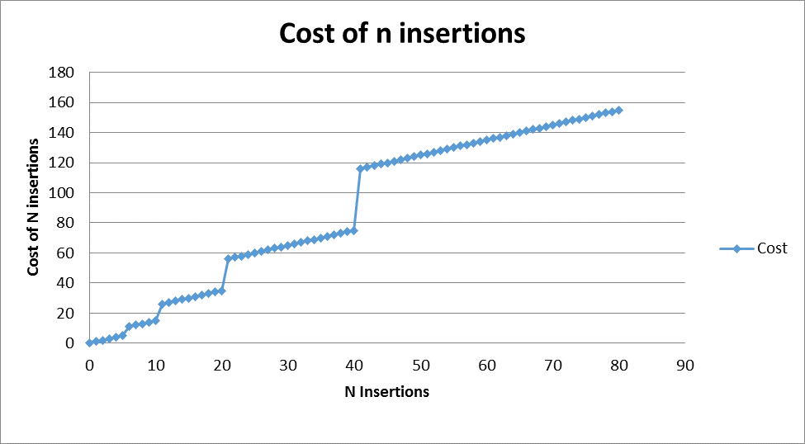
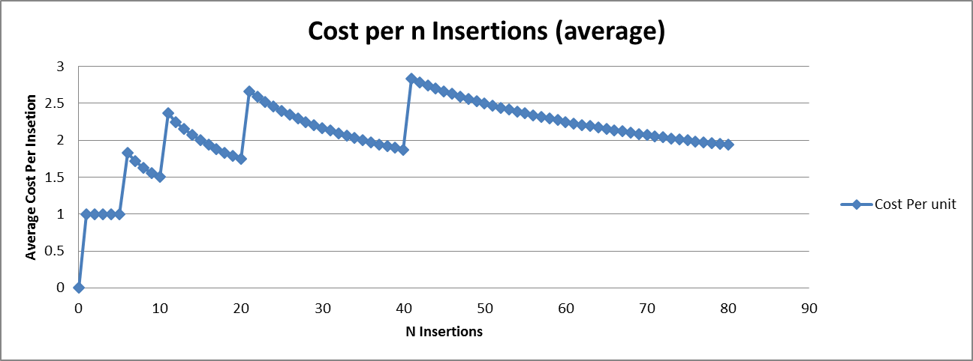

Logical Write up Developed by Eddie:
The number of units used in 25 consecutive add operations is 60 units of time, resulting in an average of 2.4 units per operation. Imagine 6 add operations. The first 5 take constant time because no resizing is involved. We then add 5 in resizing the array from 5 to 10 elements, because the size is 5, and it will take one unit for each reassignment. Finally, we add one more unit to add the 6 th element to the array. This can be expressed as 5 + 5 + 1, or 11 units of time for 6 operations. Looking at this more carefully, we can see that really, there are only two discrete units in this calculation:

1. The number of units with constant time operations.
2. The number of units involved in resizing operations.

In our example with 6 operations, we can condense 5 + 5 + 1 to 6 + 5 by folding the addition of the 6 th element into the array with the addition of the first 5, as it is also a constant time operation. Logically, this also makes sense. 6 add operations take 6 units in constant time, not factoring in the resizing.

With 25 operations, we extend this logic, factoring in where resizes are required. Assuming we double the capacity of the dynamic array with each resizing, we need to resize at 5, 10, and 20 units before arriving at the 25 th operation. By the 25 th consecutive add operation, the array will have a size of 25 and a capacity of 40. Because O(n) complexity adds a number of time units equivalent to the size of the array at each resizing, we can simply add the resizing operation elements together. 5 + 10 + 20 sums up to be 35 time units expended in resizing, while with 25 consecutive add operations, there are 25 units expended in constant time operations. 25 + 35, yields us 60 units of time, the sum of constant time operations and O(n) resizing operations.

Finally, we can derive the amortized average of 2.4 time units per operation by dividing 60 by25.

